**The Secure Sockets Layer (SSL) Protocol**

**What is SSL?**

* A protocol developed by Netscape.
* It is a whole new layer of protocol which operates above the Internet TCP protocol and below high-level application protocols.
* SSL is a standard security protocol for establishing encrypted links between a web server and a browser in an online communication.
* The usage of SSL technology ensures that all data transmitted between the web server and browser remains encrypted.

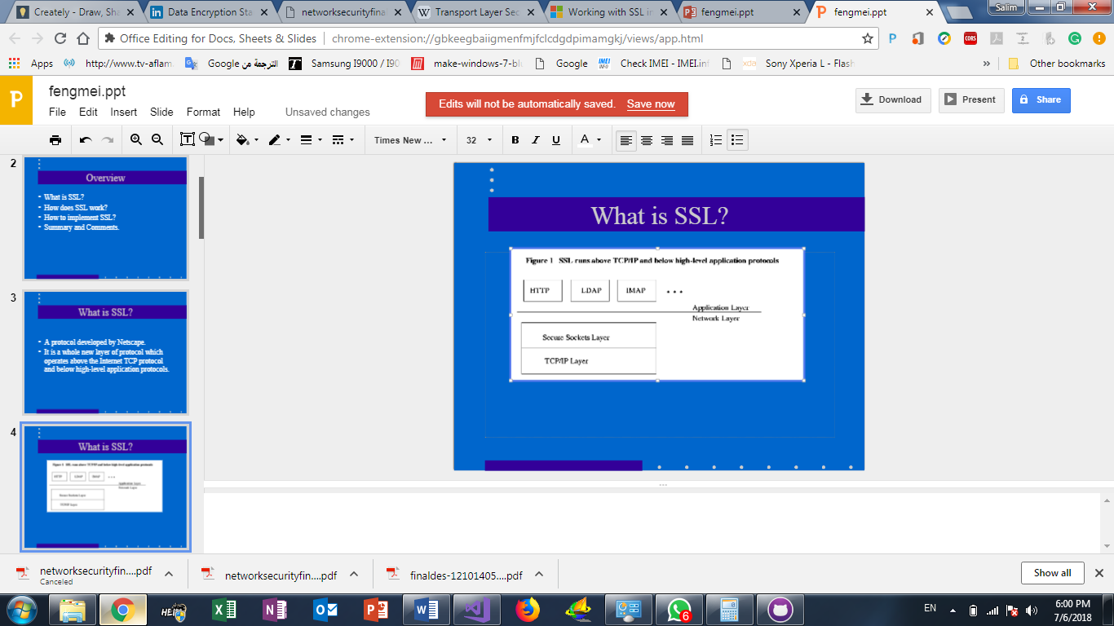

**What Can SSL Do?**

* SSL uses TCP/IP on behalf of the higher-level protocols.
* Allows an SSL-enabled server to authenticate itself to an SSL-enabled client;
* Allows the client to authenticate itself to the server;
* Allows both machines to establish an encrypted connection.
* SL server authentication.
* SSL client authentication. (optional)
* An encrypted SSL connection or Confidentiality. This protects against electronic eavesdropper.
* Integrity. This protects against hacker.

**How we apply SLL in our system?**

When Clients use HTTP to access the site, the system use an action filter to require SSL for the protected resources. The following code shows a Web API authentication filter that checks for SSL:

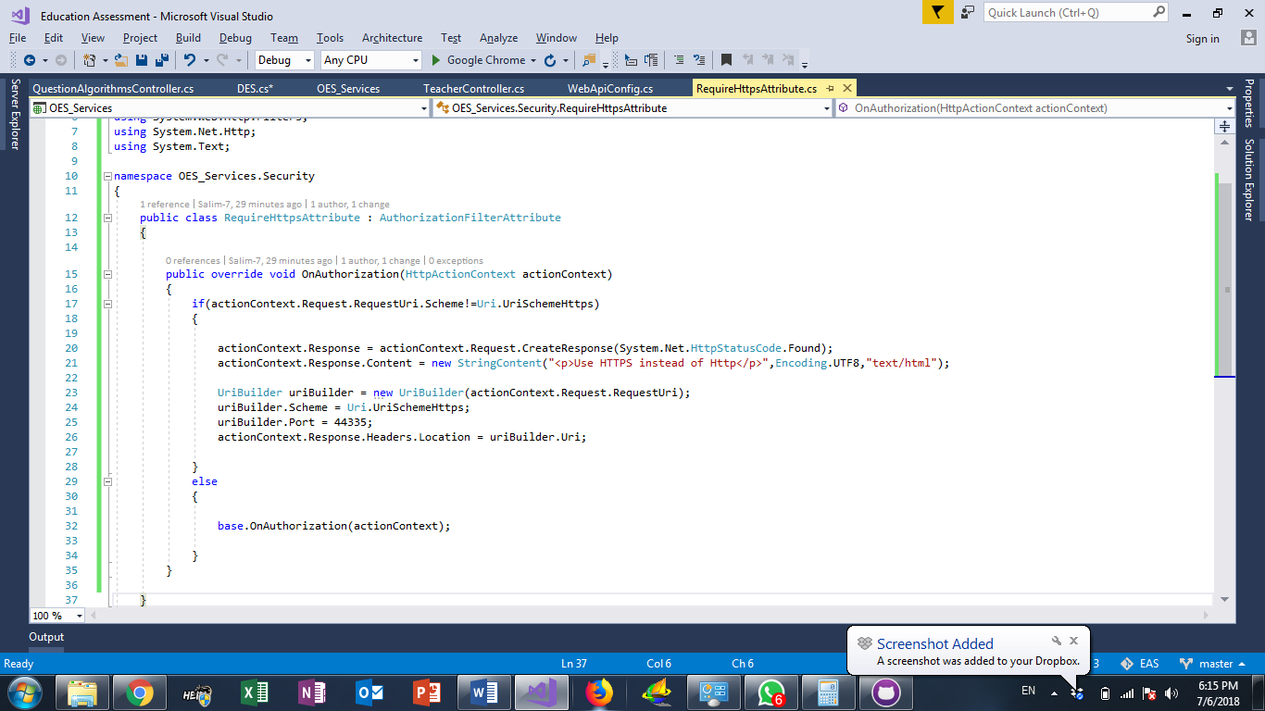

thesystem applies filter RequireHttpsAttribute in WebApiConfig:

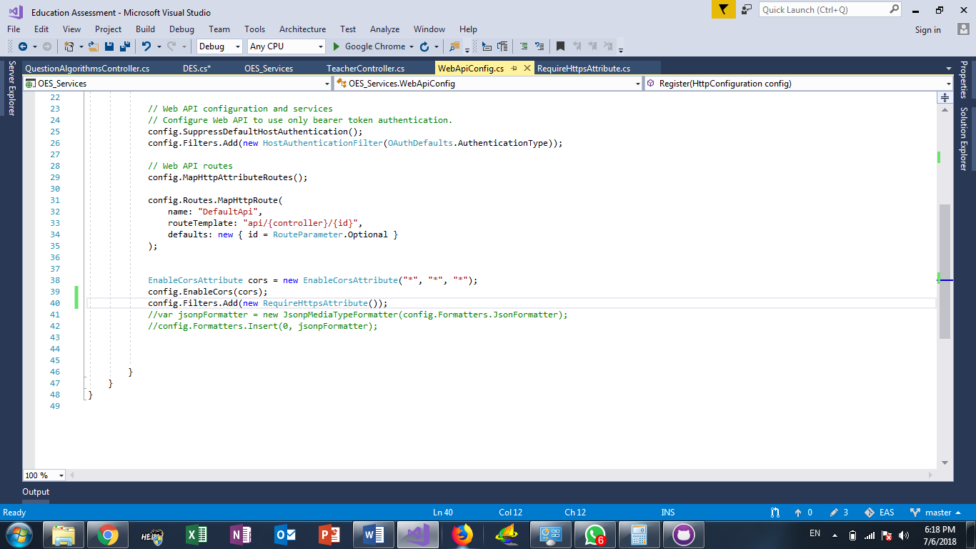

When Clients call any a controller with http, the server uses https instead of http:

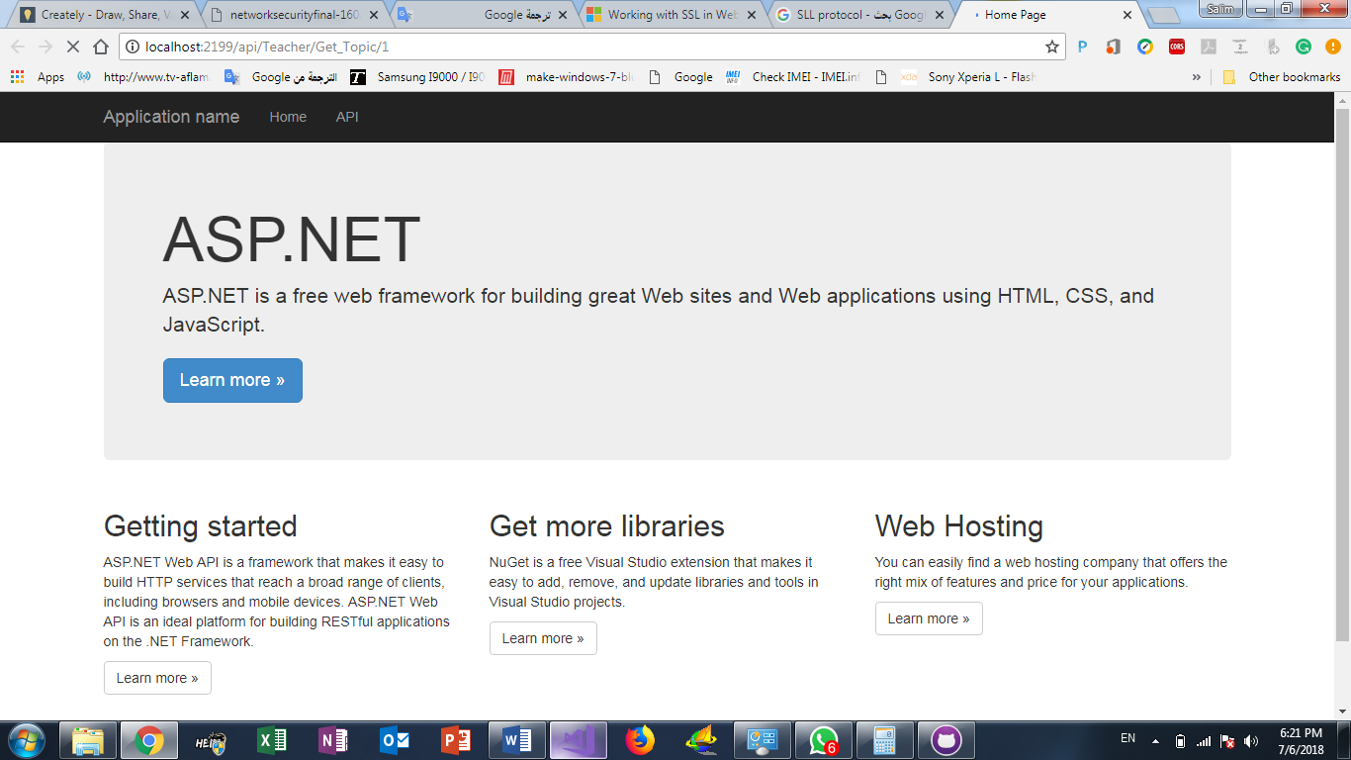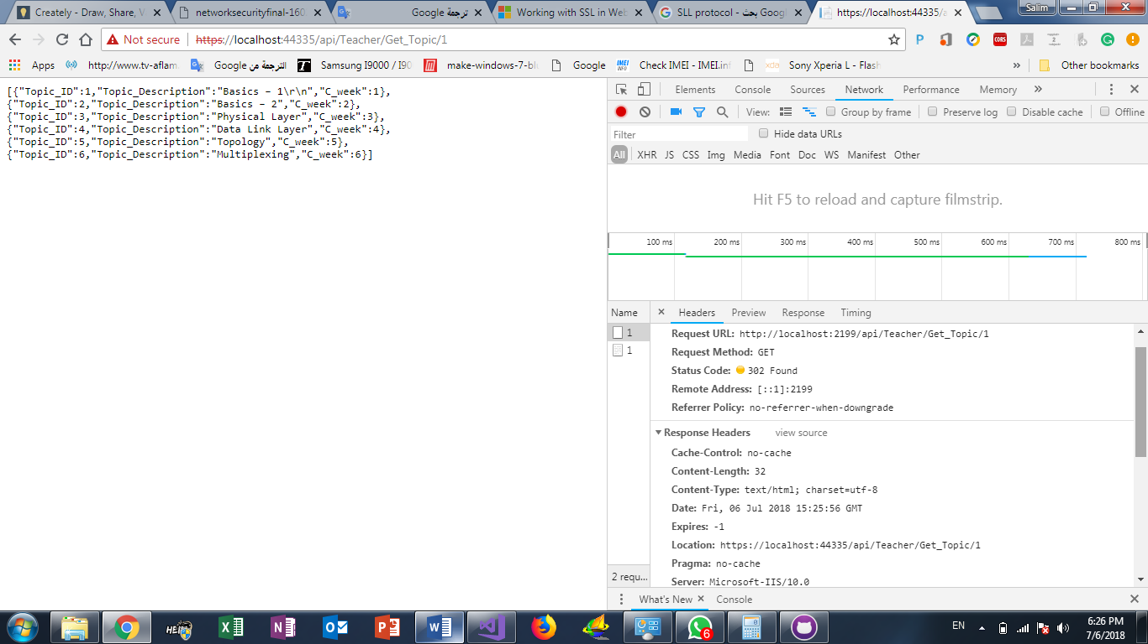

Convert from http to https

